 HUMAN BIOLOGICAL

SCIENCE

STAGE 3

2017

Name: _______________________________________________________

Teacher: ___________________________________________________

# *TIME ALLOWED FOR THIS PAPER*

## Reading time before commencing work: Ten minutes

Working time for the paper: Three hours

# *MATERIALS REQUIRED/RECOMMENDED FOR THIS PAPER*

**To be provided by the supervisor:**

* This Question/Answer Booklet
* Multiple Choice Answer Sheet

**To be provided by the candidate:**

* Standard items: Pens, pencils, eraser or correction fluid, ruler, highlighter, ruler.
* Special items: Non- graphics calculators satisfying the conditions set by the Curriculum Council for this subject.

# *IMPORTANT NOTE TO CANDIDATES*

* No other items may be taken into the examination room. It is **your** responsibility to ensure that you do not have any unauthorised notes or other items of a non-personal nature in the examination room. If you have any unauthorised material with you, hand it to the supervisor **before** reading any further.
* Test papers must be withdrawn after use and stored securely in the school until Friday, June 16.

***Structure of this paper***

|  |  |  |  |  |  |
| --- | --- | --- | --- | --- | --- |
| Section | Suggested working time | Number of questions available | Number of questions to be attempted | Marks | Percentage |
| SECTION ONE:  Multiple-choice | 50 minutes | 30 | All | 60 | 30 |
| SECTION TWO:  Short answers | 90 minutes | 9 | All | 100 | 50 |
| SECTION THREE:  Extended answers | 40 minutes | 3 | 2 | 40 | 20 |
|  |  |  | Total marks | 200 | 100 |

**Instructions to candidates**

1. The rules for the conduct of Western Australian external examinations are detailed in the *Year 12 Information Handbook 2017.* Sitting this examination implies that you agree to abide by these rules.

2. Answer the questions according to the following instructions.

Section One: Answer all questions on the separate Multiple-choice Answer Sheet provided. For each question shade the box to indicate your answer. Use only a blue or black pen to shade the boxes. If you make a mistake, place a cross through that square, do not erase or use correction fluid, and shade your new answer. Marks will not be deducted for incorrect answers. No marks will be given if more than one answer is completed for any question.

Sections Two and Three: Write your answers in this Question/Answer Booklet.

3. You must be careful to confine your responses to the specific questions asked and to follow any instructions that are specific to a particular question.

4. Spare pages are included at the end of this booklet. They can be used for planning your responses and/or as additional space if required to continue an answer.

* + Planning: If you use the spare pages for planning, indicate this clearly at the top of the page.
  + Continuing an answer: If you need to use the space to continue an answer, indicate in the original answer space where the answer is continued, i.e. give the page number. Fill in the number of the question(s) that you are continuing to answer at the top of the page.

**Section One: Multiple-choice 30% (60 Marks)**

This section has **30** questions. Answer **all** questions on the separate Multiple-choice Answer Sheet provided. For each question shade the box to indicate your answer. Use only a **blue or black pen** to shade the boxes. If you make a mistake, place a cross through that square, do not erase or use correction fluid, and shade your new answer. Marks will not be deducted for incorrect answers. No marks will be given if more than one answer is completed for any question.

Suggested working time for this section is 50 minutes.

**The following information is needed to answer the next FOUR questions.**

A patient has complained of the following symptoms to their doctor:

* Feeling a lack of energy
* Unexplained weight gain
* Feeling cold, even though the surrounding temperature is around 25°C.

In response, the doctor had the patient’s Thyroid Stimulating Hormone (TSH) levels tested over five

consecutive days. The patient’s results, measured in milli-international units per litre (mIU/L), can be

seen in the table below.

|  |  |  |  |  |  |
| --- | --- | --- | --- | --- | --- |
| Day | 1 | 2 | 3 | 4 | 5 |
| TSH concentration (mlU/L) | 2.0 | 2.3 | 2.9 | 2.7 | 2.1 |

A normal range is between 0.4 to 4.0 mIU/L.

1. The range and median for the patient’s TSH level was
2. 2.0 to 2.9 with a median of 2.4
3. 2.1 to 2.9 with a median of 2.3
4. 2.0 to 2.1 with a median of 2.9
5. 2.0 to 2.9 with a median of 2.3
6. TSH is a hormone secreted by
7. the hypothalamus and released from the anterior lobe of pituitary gland.
8. the posterior lobe of the pituitary gland and its release is controlled by the hypothalamus.
9. the anterior lobe of the pituitary gland and its release is controlled by the thyroid gland.
10. the anterior lobe of the pituitary gland and its release is controlled by the hypothalamus.
11. Based on the information the patient provided, the disease the doctor was most likely checking for was
12. type 1 diabetes.
13. type 2 diabetes.
14. hypothyroidism.
15. hyperthyroidism.
16. Choose the two correct words to complete the following sentence.

*Given the results showed a normal level of TSH present in the blood, the doctor would now need to detect for the presence of __________ to determine if the ________ gland was dysfunctional.*

1. insulin, pancreas
2. thyroxine, parathyroid
3. cortisol, adrenal medulla
4. thyroxine, thyroid
5. Which of the following illustrates a negative feedback mechanism?
6. The loss of excess glucose in urine.
7. The secretion of oily substances from the sebaceous glands to reduce water

lost from the skin surface.

1. The vasoconstriction of the capillaries in the skin to reduce heat loss.
2. The mother feeds the baby with breast milk so that the useful nutrients go

back to the human body again.

1. Many nerve fibres consist of an axon and its myelin sheath. This myelin sheath is
2. responsible for the colour of the grey matter in the brain and spinal cord.
3. produced by Schwann cells located along the axon.
4. continuous all the way along the cell body.
5. responsible for the colour of the grey matter in the peripheral nervous system.
6. One hormone molecule causes the manufacture or activation of thousands of enzyme molecules through the process of
7. negative feedback.
8. enzyme amplification.
9. hormone amplification.
10. hormone clearance.

8. The use of vaccinations has received a lot of media attention in the last few years. Parents can be quite cautious regarding the use of vaccines. One of the most common concerns is the testing of vaccines on live animals. This is best described as

a) a social concern.

b) a cultural concern.

c) an economic concern.

d) an ethical concern.

**Refer to the following diagram, showing the processes involved in labour, to answer the**

**next THREE questions.**

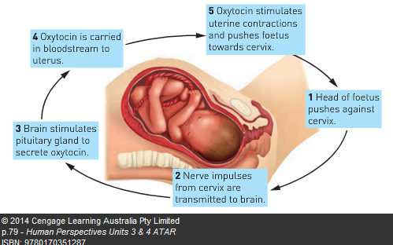

9. In this stimulus-response and feedback process, the effector would be the

1. cervix.
2. uterus.
3. pituitary gland.
4. oxytocin.

10. The type of feedback involved in this process would be

1. negative feedback, as the response negates the stimulus.
2. positive feedback, as the response negates the stimulus.
3. negative feedback, as the response intensifies the stimulus.
4. positive feedback, as the response intensifies the stimulus.

11. The hormone responsible for stimulating the contractions of the uterus is

1. produced in and released from the anterior lobe of the pituitary.
2. produced in the hypothalamus and sent to the anterior lobe of the

pituitary via nerve fibres.

1. produced in the hypothalamus and sent to the posterior lobe of the

pituitary via nerve fibres.

1. secreted from the hypothalamus and sent to the posterior lobe of the

pituitary via blood vessels in the infundibulum.

12. Which of the following statements about the autonomic nervous system is INCORRECT?

1. It regulates the activities of smooth muscle, cardiac muscle and glands.
2. It usually operates without conscious control.
3. It is regulated by centres in the cerebral cortex, hypothalamus and the medulla.
4. It contains motor and sensory nerve fibres.

**Refer to the list below to answer the next question. This information shows some**

**normal physiological changes in the human body.**

* + 1. Dilation of pupils.
    2. Increase in heart rate.
    3. Decreased secretion of saliva.
    4. Increased secretion from sweat glands.
    5. Dilation of blood vessels in the skin.
    6. Decreased levels of adrenalin in blood.

13. Which of the changes in the above list would result from stimulation by the sympathetic division of the autonomic nervous system?

1. A, B, C and E
2. A, C, D and F
3. A, B, C, and D
4. B, C, E, and F

14. Substantial injury to the right cerebral cortex results in loss of:

1. voluntary muscular movements of the left side of the body.
2. voluntary muscular movements of the right side of the body.
3. involuntary muscular movements of the left side of the body.
4. involuntary muscular movements of the right side of the body.

**Refer to the diagram below to answer the next question.**

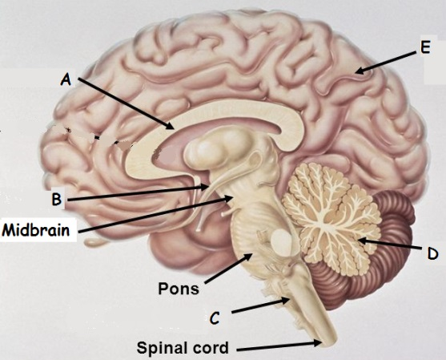

15. Which of the following correctly identifies the structures of the central nervous system?

|  |  |  |  |  |  |
| --- | --- | --- | --- | --- | --- |
|  | A | B | C | D | E |
|  | Cerebellum | Hypothalamus | Corpus Callosum | Cerebrum | Pituitary Gland |
|  | Corpus Callosum | Hypothalamus | Medulla Oblongata | Cerebellum | Cerebrum |
|  | Hypothalamus | Corpus Callosum | Medulla Oblongata | Cerebellum | Cerebrum |
|  | Corpus Callosum | Hypothalamus | Cerebellum | Medulla Oblongata | Cerebrum |

16. The sinoatrial (SA) node controls heart rate and is under autonomic control from which part of the brain?

1. Medulla oblongata.
2. Cerebellum.
3. Cerebral cortex.
4. Hypothalamus.

17. Which of the following is NOT a property of a reflex?

1. They occur without any conscious thought.
2. They occur spontaneously, without a stimulus.
3. They occur using only a small number of neurons.
4. They occur in the same way each time they happen.

**Look at the diagram below and answer the following question.**

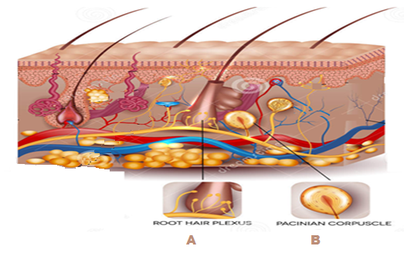

18. Choose the correct statement that describes the similarity and difference between the receptors labelled in the above diagram.

|  |  |  |
| --- | --- | --- |
|  | Similarity | Difference |
| a) | Detect heat | A detects cold, B detects heat. |
| b) | Detect pH of  body fluids | A detects low pH body fluid and B detects  high pH body fluid. |
| c) | Detect touch | A detects strong pressure, B detects light pressure. |
| d) | Detect touch | A detects light pressure, B detects strong pressure. |

19. The chemical that transmits a nerve stimulus via a somatic pathway to a muscle fibre is

1. noradrenaline.
2. cholesterol.
3. acetylcholine.
4. adenosine triphosphate.

20. A living-attenuated vaccine is best described as

1. a fragment of an organism that promotes an immune response.
2. inactivated toxins that promote an immune response.
3. dead microorganisms that promote an immune response.
4. an organism of reduced virulence that promotes an immune response.

21. The cerebrospinal fluid (CSF) is important in protecting the nervous system.

Which of the following statements about this fluid is correct?

1. The CSF occupies a space between the middle and inner layers of the meninges,

where the brain is suspended within this fluid.

1. The CSF acts as a shock absorber, protecting the whole nervous system.
2. The CSF is formed from blood and it circulates through the peripheral nervous system.
3. During its circulation, the CSF takes nutrients to the cells of the brain and spinal cord,

re-entering the lymphatic system.

22. A footballer, having received a blow to the head, has come off the field. She complains of having blurred vision. The most likely point of contact would have been the

1. front of the head.
2. left hand-side of the head.
3. right hand-side of the head.
4. rear of the head.

23. Which of the following is true about active immunity?

1. The antibody formed will attack any pathogen.
2. Both B and T lymphocytes can play a role.
3. It is short-lived because no memory cells are involved.
4. Prepared immunoglobulins activate this type of immunity.

24. An individual contracted Lyme disease after a tick took a blood meal from them.

Which of the following methods would describe how this disease was transmitted?

1. By contact
2. By body fluids
3. By a vector
4. By ingestion

25. The enzyme that is found in human tears that helps to kill bacteria is called

1. cerumen.
2. lysozyme.
3. vaccine.
4. leukocyte.

26. Which of the following organs in LIST 1 correctly matches the mode of defence against a possible pathogen in LIST 2?

|  |  |  |
| --- | --- | --- |
|  | LIST 1 | LIST 2 |
| a) | Trachea | Hairs and mucus |
| b) | Stomach | Impervious barrier |
| c) | Skin | Sebum and sweat |
| d) | Urethra | Digestive enzymes |

27. When B lymphocytes bind to an antigen they undergo cell division to produce a

1. macrophage and a memory cell.
2. memory cell and a killer T cell.
3. plasma cell and a macrophage.
4. plasma cell and a memory cell.

28. Which of the following is NOT an example of a pathogen?

1. Mosquito.
2. Bacteria.
3. Protozoan.
4. Fungi.

29. When an individual experiences a rapid onset of a fever they may feel

1. cold and, as a consequence, vasodilation in the skin and shivering occurs.
2. hot and, as a consequence, vasoconstriction in the skin and sweating occurs.
3. cold and, as a consequence, vasoconstriction in the skin and shivering occurs.
4. hot and, as a consequence, vasodilation in the skin and shivering occurs.

30. Vaccination programs that reduce the chance of disease in individuals and increase the immunity of a population is best described as

1. natural passive immunity.
2. artificial passive immunity.
3. natural active immunity.
4. herd immunity.

**Section Two: Short answer 50% (100 Marks)**

This section has **nine (9)** questions. Answer **all** questions.

Write your answers in the spaces provided.

Spare pages are included at the end of this booklet. They can be used for planning your responses and/or as additional space if required to continue an answer.

Planning: If you use the spare pages for planning, indicate this clearly at the top of the page.

Continuing an answer: If you need to use the space to continue an answer, indicate in the original answer space where the answer is continued, i.e. give the page number. Fill in the number of the question(s) that you are continuing to answer at the top of the page.

Suggested working time for this section is 90 minutes.

31. **(16 marks)**

Type 1 diabetics inject insulin everyday in order to control their blood glucose. There are several different forms of insulin available for them to use. An investigation was carried out to compare the activity of two forms of human insulin- X and Y. One group of diabetics injected themselves with insulin-X while the second group injected themselves with insulin-Y.

Blood samples were taken at hourly intervals over a 20-hour period.

A sample of the results are shown in table 1 below.

Table 1

|  |  |  |
| --- | --- | --- |
| Time after injection (hours) | Insulin-X  Mean insulin activity (arbitrary units) | Insulin-Y  Mean insulin activity (arbitrary units) |
| 1 | 0.4 | 1.2 |
| 5 | 3.4 | 1.0 |
| 7 | 2.8 | 0.8 |
| 9 | 1.9 | 0.7 |
| 11 | 1.2 | 0.8 |
| 15 | 0.5 | 1 |
| 17 | 0.2 | 0.9 |
| 19 | 0.1 | 1 |

(a) Graph these results on the grid provided. (5 marks)

*A spare grid is provided at the end of this Question/ Answer booklet. If you need to use it, cross out this attempt.*

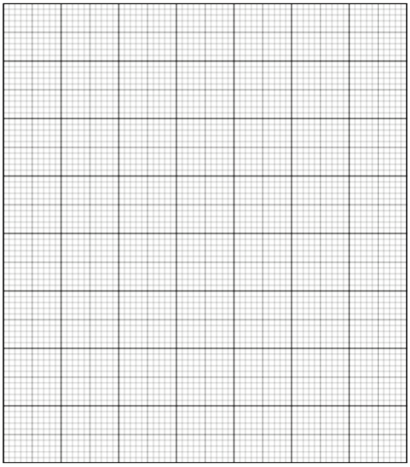

(b) Using the information in the graph, compare the action of Insulin-X and Insulin-Y.

___________________________________________________________________________

___________________________________________________________________________

___________________________________________________________________________

___________________________________________________________________________

___________________________________________________________________________

___________________________________________________________________________

___________________________________________________________________________

(4 marks)

(c) Two hormones associated with a stress response are cortisol and adrenaline.

Compare and contrast these two hormones.

___________________________________________________________________________

___________________________________________________________________________

___________________________________________________________________________

___________________________________________________________________________

___________________________________________________________________________

___________________________________________________________________________

___________________________________________________________________________

___________________________________________________________________________

___________________________________________________________________________

___________________________________________________________________________

___________________________________________________________________________

___________________________________________________________________________

___________________________________________________________________________

___________________________________________________________________________

(7 marks)

32. **(8 marks)**

Scientists investigated the effects of aging on reaction time. They recruited people from two age groups: 15-25 and 65-75.

The people in each group were all of a similar fitness level and no one reported any significant health issues.

Each person was given an iPad. A set of traffic lights was displayed on the screen. The lights changed from red to orange to green. Each person was asked to tap the ipad when the light turned green. The test was repeated 10 times.

Graph 1 below shows the average results for each group.

Graph 1

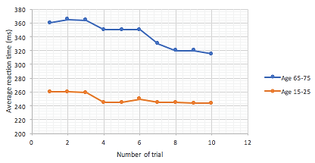

(a) Write a suitable hypothesis for this investigation.

___________________________________________________________________________

___________________________________________________________________________

(2 marks)

(b) Explain why it is necessary to repeat the experiment.

___________________________________________________________________________

___________________________________________________________________________

(1 mark)

(c) Identify two (2) factors that would have to be controlled during this experiment.

___________________________________________________________________________

___________________________________________________________________________

(2 marks)

(d) Explain one reason for the difference in reaction time between older and younger people.

___________________________________________________________________________

___________________________________________________________________________

(1 mark)

(e) Were the results of the investigation valid? Explain your answer.

___________________________________________________________________________

___________________________________________________________________________

___________________________________________________________________________

(2 marks)

33.  **(9 marks)**

The amount of water being taken into the body must equal the amount of water leaving the body. If the water lost is in excess of water gained, we are at risk of suffering from dehydration. Symptoms of dehydration range from a dry mouth and decrease in sweat production to more severe symptoms; confusion, lack of blood flow to vital organs and eventually death.

(a) Describe the homeostatic mechanism that controls body fluids when osmotic pressure increases.

__________________________________________________________________________________________________________________________________________________________________________________________________________________________________________________________________________________________________________________________________________________________________________________________________________________________________________________________________________________________________________________________________________________________________________________________________________________________________________________________________________________________________________________________________________________________

(6 marks)

(b) Explain why it is possible for us to state that the hormone aldosterone indirectly affects the level of water in the blood.

_____________________________________________________________________________________________________________________________________________________________________________________________________________________________________________________________________________________________________________________________________________________________________________

(3 marks)

34. **(13 marks)**

1. Complete the diagram below of a reflex arc, by drawing a myelinated unipolar neuron in the appropriate space below. (1 mark)

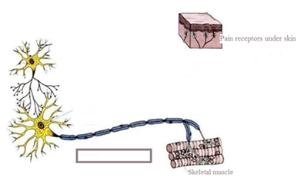

X

1. Indicate with an arrow in the rectangular box above labelled X, the direction of the nerve impulse through the axon. (1 mark)
2. Complete the following table.

|  |  |
| --- | --- |
| **Part** | **Function** |
| Cell Body |  |
| Dendrites |  |
| Myelin sheath |  |
| Axon |  |

(4 marks)

(d) Label the parts listed in the above table onto the multipolar neuron in the diagram above.

(4 marks)

(e) Label each neuron in the diagram above according to their functional type.

(3 marks)

35. **(13 marks)**

Below is an action potential graph, showing the outcome from two different stimuli on the same neuron. Looking at the graph below, answer the questions that follow.

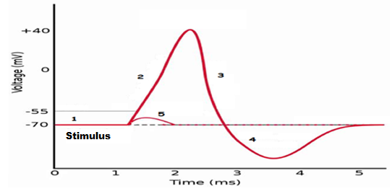

1. The first stimulus resulted in the line labelled with the number 5. State TWO reasons why the potential difference quickly returned to -70mV.

_____________________________________________________________________________________________________________________________________________________________________________________________________________________

(2 marks)

1. The second stimulus resulted in the line labelled with the numbers 2, 3 and 4.

State TWO events that could not possibly occur during the phases shown by the sections labelled 2, 3 and 4.

____________________________________________________________________________________________________________________________________________________________________________________________________________________________________________________________________________________________________________

(2 marks)

1. Label the following diagrams with the numbers from the above graph, to show what would be occurring with the ions and their respective channels during an action potential.

|  |  |
| --- | --- |
| Number: ______ | Number: ______ |

(1 mark)

1. Looking at the action potential graph on the previous page, locate the section labelled with a 1.

In the box below draw a labelled diagram (similar to those shown in © above) of this section to show:

1. The location of the sodium and potassium ions and, if they are moving, the direction

the ions would be travelling.

1. The gated channels and whether they are open or closed.
2. The charge either side of the neuron membrane.

(3 marks)

1. Look at the diagram below of the different nerve fibres and answer the questions that follow.

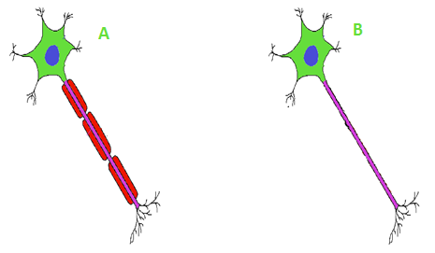

1. State which nerve fibres shown above would be myelinated or unmylinated and

whether they would be found in grey or white matter.

A ________________________________________

B ________________________________________

(2 marks)

1. State which of the nerve fibres above would conduct an impulse faster and

briefly explain why.

___________________________________________________________________________

___________________________________________________________________________

___________________________________________________________________________

___________________________________________________________________________

___________________________________________________________________________

___________________________________________________________________________

___________________________________________________________________________

(3 marks)

36. **(13 marks)**

The graph below shows the immune response of a person to a bacterial infection. Refer to the graph to answer the following questions.

Immune response to bacterial infection.

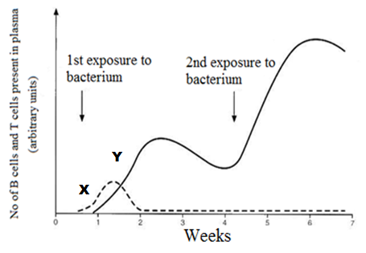

(a) State which of the lines (X or Y) on the graph represents the cloning of B cells. Explain why you made your choice.

____________________________________________________________________________________________________________________________________________________________________________________________________________________________________________________________________________________________________________

(2 marks)

(b) The number of cells represented by the Y line after the second exposure was greater and their production was much faster, despite the person never receiving a vaccination. Explain what allowed this to happen.

____________________________________________________________________________________________________________________________________________________________________________________________________________________________________________________________________________________________________________

(2 marks)

(c) After the first exposure to the bacterium, the person experienced an elevation of their body temperature.

(i) State the name of this non-specific response. ______________ (1 mark)

(ii) State the name of two effectors and describe how their response contributed to this

non-specific defense. ____________________________________________________________________________________________________________________________________________________________________________________________________________________________________________________________________________________________________________

(2 marks)

(iii) Describe two benefits an elevated body temperature is believed to provide as the

body fights against a disease.

____________________________________________________________________________________________________________________________________________________________________________________________________________________________________________________________________________________________________________

(2 marks)

(d) There are two types of antibiotics. Name each type and describe how they kill bacteria.

__________________________________________________________________________________________________________________________________________________________________________________________________________________________________________________________________________________________________________________________________________________________________________________________________________________________________________________________________

(4 marks)

37. **(11 marks)**

Free divers are athletes who descend underwater as far as possible without breathing apparatus. Before diving into the water, the free diver deliberately hyperventilates.

State what hyperventilation is and what effect it has on the gas concentration in the blood.

_______________________________________________________________________________________________________________________________________________________________________________________________________________________________________________________________________________________________________________________________________________________________________________________

(3 marks)

Hyperventilation can occur voluntarily or involuntarily. It can occur involuntarily in response to severe pain or extreme fear.

Complete the following table to distinguish between the two different efferent nervous divisions that can regulate hyperventilation.

|  |  |  |
| --- | --- | --- |
|  | Names of two different nervous efferent divisions | |
| 1.______________________ | 2. _____________________ |
| Neurotransmitters |  |  |
| Effector(s) / target organ(s) |  |  |
| Effect of neurotransmitter on  effector(s) / target organ(s) |  |  |
| The number of neurons  between the CNS and effector |  |  |

1. marks)

Explain how voluntary hyperventilation allows the free diver to stay underwater for longer.

_______________________________________________________________________________________________________________________________________________________________________________________________________________________________________________________________________________________________________________________________________________________________________________________

(3 marks)

38.  **(5 marks)**

The pituitary gland is sometimes referred to as the “master gland”, however, it could be argued the hypothalamus should have this title. Describe how the hypothalamus controls the secretion of hormones from the anterior and posterior lobe of the pituitary gland.

________________________________________________________________________________________________________________________________________________________________________________________________________________________________________________________________________________________________________________________________________________________________________________________________________________________________________________________________________________________________________________________________________________________________________________________________________________________________________________________________________________________________________________________________________________ (5 marks)

39. **(12 marks)**

A marathon runner is just about to complete a race in hot weather and he is sweating, feels thirsty and his skin is red and hot.

1. Complete the following table to summarise the body’s symptoms to the exercise in the hot environment.

|  |  |  |  |  |  |
| --- | --- | --- | --- | --- | --- |
| **Symptoms** | **Stimulus** | **Receptor** | **Modulator** | **Effector** | **Response** |
| Red and  hot skin | Increased  body  temperature | Thermoreceptor | Hypothalamus |  |  |
| Sweating | Increased  body  temperature | Thermoreceptor |  | Sweat glands | Sweat released  onto the surface of  this skin |
| Thirsty | Increased  osmotic  pressure |  | Hypothalamus |  | Conscious decision  to have a drink |

(5 marks)

(b) After the race, despite the large volumes of plain water consumed by the athlete,

he feels light headed, has a headache and feels nauseous.

As a result of the light headedness, the athlete stumbled forwards and grazed his hands. The palms of his hands are now bleeding, red, swollen, hot and painful.

1. Based on the symptoms listed, name the internal non-specific defensive response that

has been stimulated as a result of the injury.

______________________________________________________________ (1 mark)

(ii) Describe the sequence of events that would keep the wound free of infection and

allow the wound to heal.

________________________________________________________________________________________________________________________________________________________________________________________________________________________________________________________________________________________________________________________________________________________________________________________________________________________________________________________________________________________________________________________________________________________________________________________________________________________

(6 marks)

**Section Three: Extended answer 20% (40 Marks)**

This section contains **three (3)** questions. You must answer **two (2)** questions. Make sure you clearly indicate which question you are answering and write your answers in the space provided.

Spare pages are included at the end of this booklet. They can be used for planning your responses and/or as additional space if required to continue an answer.

* Planning: If you use the spare pages for planning, indicate this clearly at the top of the page.
  + Continuing an answer: If you need to use more space to continue an answer, indicate in the original answer space where the answer is continued, i.e. give the page number. Write the number of the question(s) that you are continuing to answer at the top of the additional space page.

Responses could include clearly labelled diagrams with explanatory notes; lists of points with linking sentences; clearly labelled tables and graphs; and annotated flow diagrams with introductory notes.

Suggested working time: 40 minutes.

40. **(20 marks)**

(a) The neurotransmitter dopamine stimulates target neurones in the same manner as an amine hormone would affect a target cell. It can have an excitatory or inhibitory effect on the action potential of the target neuron, depending on whether it has D1 or D2 receptors. If the neuron has D1 receptors, sodium ion (Na+) channels are stimulated to be opened and if the neuron has D2 receptors, potassium ion (K+) channels are stimulated to open.

1. Using a labelled diagram, describe how dopamine would move from the presynaptic

neuron, across the synapse, to enter and activate a specific target neuron.

(5 marks)

(ii) State whether the D2 receptors would cause an excitatory or inhibitory effect on the action potential of the target neuron and describe why this response would occur.

(5 marks)

(b) Cocaine prevents the reabsorption of dopamine and noradrenaline (norepinephrine) into the axon of the presynaptic neuron. This action has its greatest effect on those neurones with D1 receptors.

(i) State whether the constant supply of dopamine would stimulate the presynaptic

neuron to be depolarised or remain polarised and describe why this would occur.

(4 marks)

(ii) The constant supply of noradrenaline would stimulate the autonomic nervous system. State which division of the autonomic nervous system would be stimulated and describe how five different parts of the body would be affected by this neurotransmitter.

(6 marks)

41. **(20 marks)**

*Bacillus cereus* is a bacterium that can cause food poisoning, usually contracted from rice meals which have been allowed to rest at room temperature for hours, particularly at a buffet. If the bacterium is exposed to high temperatures or acidic conditions, they will enter a dormant state and develop a heat and chemical resistant cell wall, until their surrounding environment is favourable again. This dormant and protective state is referred to as being an endospore.

An infection is initially indicated by vomiting and/or diarrhoea and then 30 minutes to 6 hours later the lymph glands/nodes can become swollen and there is a spike in body temperature. Most patients recover within 6 to 24 hours.

1. Describe how the non-specific defences initially triggered in response to the infection destroy or remove some of the *Bacillus cereus* and explain why they are incapable of completely eradicating the bacteria.

(10 marks)

(b) The swollen lymph nodes are an indication of the specific defences the body employed to destroy the bacterium. State what an antibody is and describe the steps that would occur during a humoral response.

(10 marks)

42. **(20 marks)**

Under normal circumstances, homeostatic control mechanisms ensure blood glucose levels (BGLs) are maintained at a constant level. People with diabetes mellitus are incapable of maintaining their BGLs and they can experience increased urination (polyuria) if they consume a meal high in glucose.

1. Explain how the pancreas and liver would reduce the BGLs in someone who was not a diabetic. (5 marks)
2. Explain the cause and treatments of type 1 and type 2 diabetes. (6 marks)
3. The high amounts of glucose in a diabetic’s blood plasma can lead to a high osmotic pressure within the blood plasma.

Describe what effect this stimulus would have on the action of antidiuretic hormone (ADH) in controlling water balance and explain why a diabetic would urinate excessively and feel thirsty.

(9 marks)

Question number: __________________

________________________________________________________________________________

________________________________________________________________________________

________________________________________________________________________________

________________________________________________________________________________

________________________________________________________________________________

________________________________________________________________________________

________________________________________________________________________________

________________________________________________________________________________

________________________________________________________________________________

________________________________________________________________________________

________________________________________________________________________________

________________________________________________________________________________

________________________________________________________________________________

________________________________________________________________________________

________________________________________________________________________________

________________________________________________________________________________

________________________________________________________________________________

________________________________________________________________________________

________________________________________________________________________________

________________________________________________________________________________

________________________________________________________________________________

________________________________________________________________________________

________________________________________________________________________________

________________________________________________________________________________

________________________________________________________________________________

________________________________________________________________________________

________________________________________________________________________________

________________________________________________________________________________

________________________________________________________________________________

________________________________________________________________________________

________________________________________________________________________________

________________________________________________________________________________

________________________________________________________________________________

________________________________________________________________________________

Question number: __________________

________________________________________________________________________________

________________________________________________________________________________

________________________________________________________________________________

________________________________________________________________________________

________________________________________________________________________________

________________________________________________________________________________

________________________________________________________________________________

________________________________________________________________________________

________________________________________________________________________________

________________________________________________________________________________

________________________________________________________________________________

________________________________________________________________________________

________________________________________________________________________________

________________________________________________________________________________

________________________________________________________________________________

________________________________________________________________________________

________________________________________________________________________________

________________________________________________________________________________

________________________________________________________________________________

________________________________________________________________________________

________________________________________________________________________________

________________________________________________________________________________

________________________________________________________________________________

________________________________________________________________________________

________________________________________________________________________________

________________________________________________________________________________

________________________________________________________________________________

________________________________________________________________________________

________________________________________________________________________________

________________________________________________________________________________

________________________________________________________________________________

________________________________________________________________________________

________________________________________________________________________________

________________________________________________________________________________

Question number: __________________

________________________________________________________________________________

________________________________________________________________________________

________________________________________________________________________________

________________________________________________________________________________

________________________________________________________________________________

________________________________________________________________________________

________________________________________________________________________________

________________________________________________________________________________

________________________________________________________________________________

________________________________________________________________________________

________________________________________________________________________________

________________________________________________________________________________

________________________________________________________________________________

________________________________________________________________________________

________________________________________________________________________________

________________________________________________________________________________

________________________________________________________________________________

________________________________________________________________________________

________________________________________________________________________________

________________________________________________________________________________

________________________________________________________________________________

________________________________________________________________________________

________________________________________________________________________________

________________________________________________________________________________

________________________________________________________________________________

________________________________________________________________________________

________________________________________________________________________________

________________________________________________________________________________

________________________________________________________________________________

________________________________________________________________________________

________________________________________________________________________________

________________________________________________________________________________

________________________________________________________________________________

________________________________________________________________________________

Question number: __________________

________________________________________________________________________________

________________________________________________________________________________

________________________________________________________________________________

________________________________________________________________________________

________________________________________________________________________________

________________________________________________________________________________

________________________________________________________________________________

________________________________________________________________________________

________________________________________________________________________________

________________________________________________________________________________

________________________________________________________________________________

________________________________________________________________________________

________________________________________________________________________________

________________________________________________________________________________

________________________________________________________________________________

________________________________________________________________________________

________________________________________________________________________________

________________________________________________________________________________

________________________________________________________________________________

________________________________________________________________________________

________________________________________________________________________________

________________________________________________________________________________

________________________________________________________________________________

________________________________________________________________________________

________________________________________________________________________________

________________________________________________________________________________

________________________________________________________________________________

________________________________________________________________________________

________________________________________________________________________________

________________________________________________________________________________

________________________________________________________________________________

________________________________________________________________________________

________________________________________________________________________________

________________________________________________________________________________

Question number: __________________

________________________________________________________________________________

________________________________________________________________________________

________________________________________________________________________________

________________________________________________________________________________

________________________________________________________________________________

________________________________________________________________________________

________________________________________________________________________________

________________________________________________________________________________

________________________________________________________________________________

________________________________________________________________________________

________________________________________________________________________________

________________________________________________________________________________

________________________________________________________________________________

________________________________________________________________________________

________________________________________________________________________________

________________________________________________________________________________

________________________________________________________________________________

________________________________________________________________________________

________________________________________________________________________________

________________________________________________________________________________

________________________________________________________________________________

________________________________________________________________________________

________________________________________________________________________________

________________________________________________________________________________

________________________________________________________________________________

________________________________________________________________________________

________________________________________________________________________________

________________________________________________________________________________

________________________________________________________________________________

________________________________________________________________________________

________________________________________________________________________________

________________________________________________________________________________

________________________________________________________________________________

________________________________________________________________________________

Question number: __________________

________________________________________________________________________________

________________________________________________________________________________

________________________________________________________________________________

________________________________________________________________________________

________________________________________________________________________________

________________________________________________________________________________

________________________________________________________________________________

________________________________________________________________________________

________________________________________________________________________________

________________________________________________________________________________

________________________________________________________________________________

________________________________________________________________________________

________________________________________________________________________________

________________________________________________________________________________

________________________________________________________________________________

________________________________________________________________________________

________________________________________________________________________________

________________________________________________________________________________

________________________________________________________________________________

________________________________________________________________________________

________________________________________________________________________________

________________________________________________________________________________

________________________________________________________________________________

________________________________________________________________________________

________________________________________________________________________________

________________________________________________________________________________

________________________________________________________________________________

________________________________________________________________________________

________________________________________________________________________________

________________________________________________________________________________

________________________________________________________________________________

________________________________________________________________________________

________________________________________________________________________________

________________________________________________________________________________

Question number: __________________

________________________________________________________________________________

________________________________________________________________________________

________________________________________________________________________________

________________________________________________________________________________

________________________________________________________________________________

________________________________________________________________________________

________________________________________________________________________________

________________________________________________________________________________

________________________________________________________________________________

________________________________________________________________________________

________________________________________________________________________________

________________________________________________________________________________

________________________________________________________________________________

________________________________________________________________________________

________________________________________________________________________________

________________________________________________________________________________

________________________________________________________________________________

________________________________________________________________________________

________________________________________________________________________________

________________________________________________________________________________

________________________________________________________________________________

________________________________________________________________________________

________________________________________________________________________________

________________________________________________________________________________

________________________________________________________________________________

________________________________________________________________________________

________________________________________________________________________________

________________________________________________________________________________

________________________________________________________________________________

________________________________________________________________________________

________________________________________________________________________________

________________________________________________________________________________

________________________________________________________________________________

________________________________________________________________________________

Question number: __________________

________________________________________________________________________________

________________________________________________________________________________

________________________________________________________________________________

________________________________________________________________________________

________________________________________________________________________________

________________________________________________________________________________

________________________________________________________________________________

________________________________________________________________________________

________________________________________________________________________________

________________________________________________________________________________

________________________________________________________________________________

________________________________________________________________________________

________________________________________________________________________________

________________________________________________________________________________

________________________________________________________________________________

________________________________________________________________________________

________________________________________________________________________________

________________________________________________________________________________

________________________________________________________________________________

________________________________________________________________________________

________________________________________________________________________________

________________________________________________________________________________

________________________________________________________________________________

________________________________________________________________________________

________________________________________________________________________________

________________________________________________________________________________

________________________________________________________________________________

________________________________________________________________________________

________________________________________________________________________________

________________________________________________________________________________

________________________________________________________________________________

________________________________________________________________________________

________________________________________________________________________________

________________________________________________________________________________

________________________________________________________________________________

Additional Working.

________________________________________________________________________________

________________________________________________________________________________

________________________________________________________________________________

________________________________________________________________________________

________________________________________________________________________________

________________________________________________________________________________

________________________________________________________________________________

________________________________________________________________________________

________________________________________________________________________________

________________________________________________________________________________

________________________________________________________________________________

________________________________________________________________________________

________________________________________________________________________________

________________________________________________________________________________

________________________________________________________________________________

________________________________________________________________________________

________________________________________________________________________________

________________________________________________________________________________

________________________________________________________________________________

________________________________________________________________________________

________________________________________________________________________________

________________________________________________________________________________

________________________________________________________________________________

________________________________________________________________________________

________________________________________________________________________________

________________________________________________________________________________

________________________________________________________________________________

________________________________________________________________________________

________________________________________________________________________________

________________________________________________________________________________

________________________________________________________________________________

________________________________________________________________________________

________________________________________________________________________________

________________________________________________________________________________

________________________________________________________________________________

Spare grid for question 31 (a)

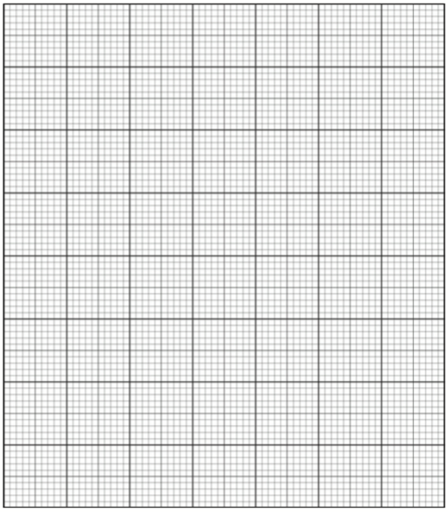

References

Question 9

Retrieved September 28, 2016, from Human Perspectives Units 3 & 4 pg 79.

Question 15

slide_37.jpg. Retrieved September 28, 2016,from <http://images.slideplayer.com/27/9180495/slides/slide_37.jpg>

Medical Art Services, Munich, Wellcome Images.

Question 18

cutaneous%2Breceptors.jpg. Retrieved December 5, 2016,from

<https://www.dreamstime.com/stock-illustration-sensory-receptors-skin-detailed-anatomy-beautiful-bright-colors-image49741056>

Under the Dreamstime license

Question 32

I10-40-nerve.jpg Retrieved September 29, 2016,from

<https://kasper-achs-block3.wikispaces.com/file/view/I10-40-nerve.jpg/226820682/436x300/I10-40-nerve.jpg>

Under the Creative Commons license.

Question 33

Action potential graph. Retrieved October 23, 2016, from

<https://i.ytimg.com/vi/HnKMB11ih2o/maxresdefault.jpg>

Under the Free Images license

Question 33 (c) images.

Retrieved October 23, 2016, from

<https://s-media-cache-ak0.pinimg.com/736x/cc/e7/29/cce729bcbb341f91a152ad2eb724fe28.jpg>

Under the Free Images license

Question 33 (e) image.

Retrieved November, 17, 2016, from

<https://upload.wikimedia.org/wikipedia/commons/8/88/Myelinated_unmylinated_neurons.PNG>

Under the Common Creatives license

WATP acknowledges the permission of School Curriculum and Assessment Authority in

providing instructions to students.